**VA Intent to File**

Hello, I hope your day has been well, in this document we will be instructing you to open your Intent To File (**ITF**) and start your VA Disability Claim. Please note we will not be submitting the application; just beginning it and inputting information.

1. We’ll start off by signing into the Veterans Affairs website va.gov and navigate to “file a claim online”.

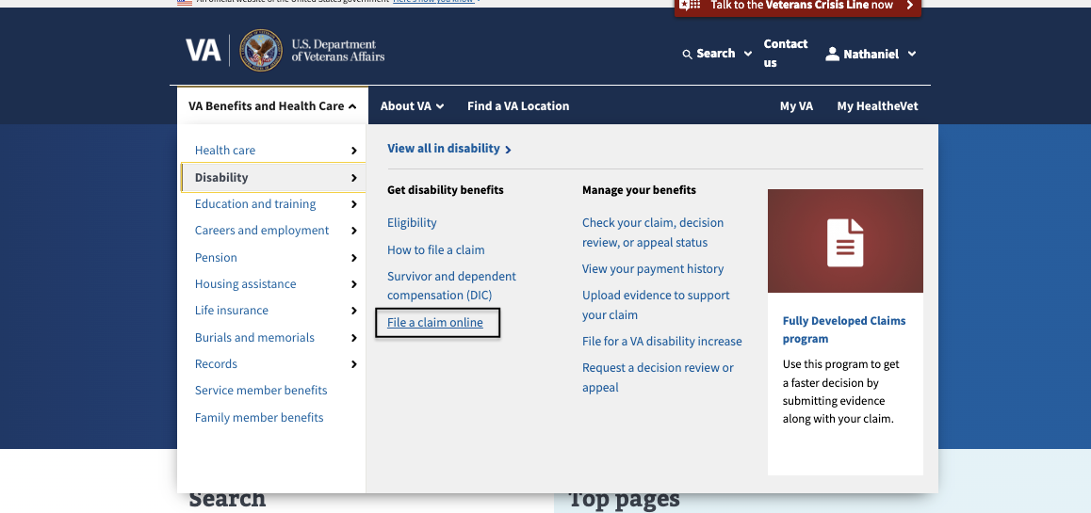

1. Next, answer the questions below as shown. Please note, if you are still Active Duty skip this process and go to the “Book An Appointment” tab on the website and fill out the questionnaire.

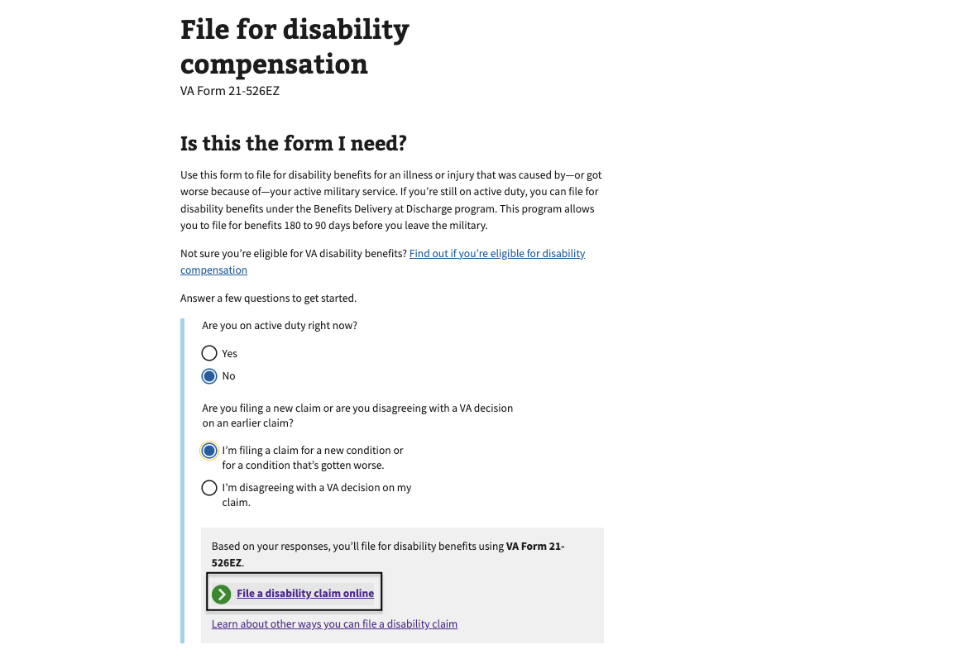

1. Now click the box below to start the applications.

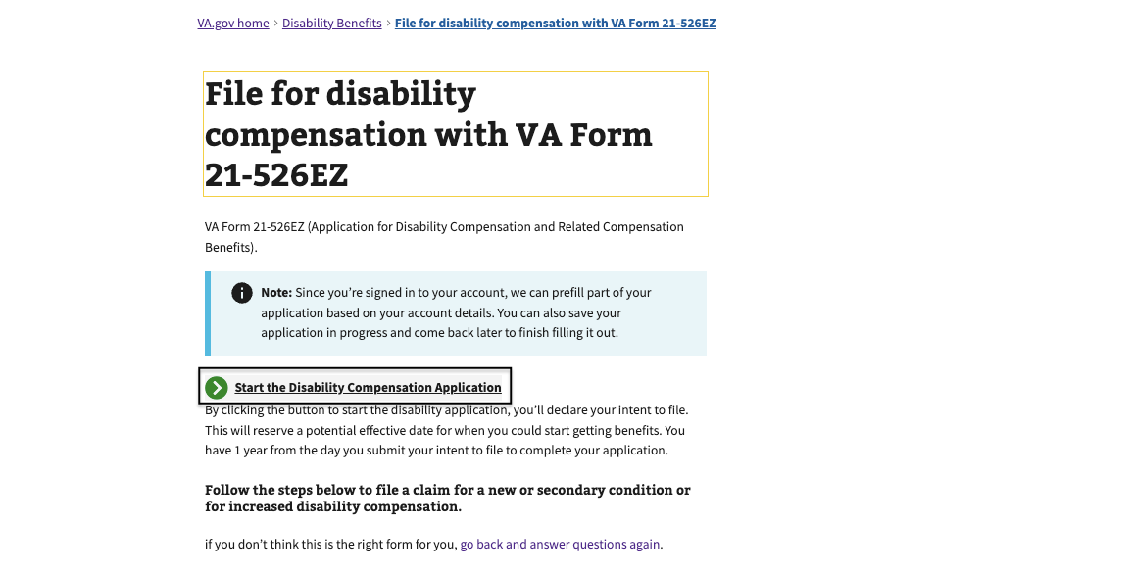

4a. Next, click through this screen here, this is for if you already have an ITF as seen on the next picture.

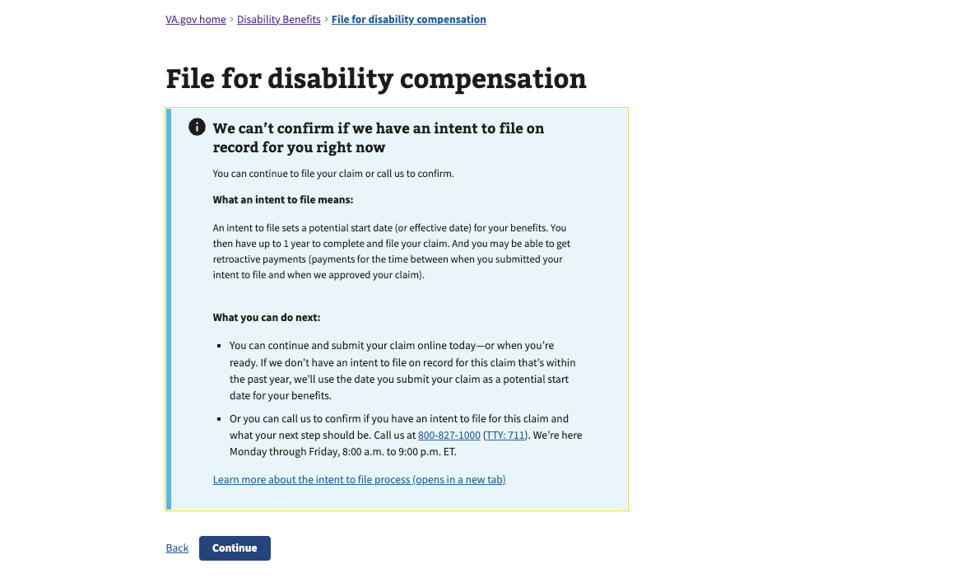

4b. If you have an ITF you’ll see this screen. If the expiration date is within the next 2 months go back to the website and navigate to “Book An Appointment” to consult with us on the next step. If it is not going to expire in the next 2 months, you’re good to go and you can move forward with sending us your documents.

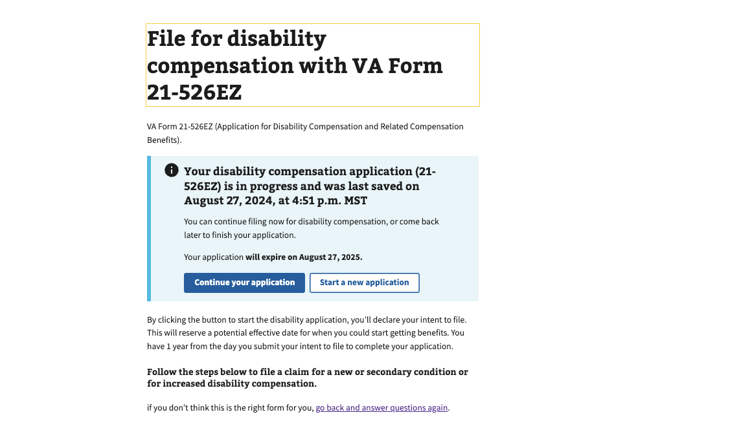

1. This is the first page of this application, please verify the information and move to the next page.

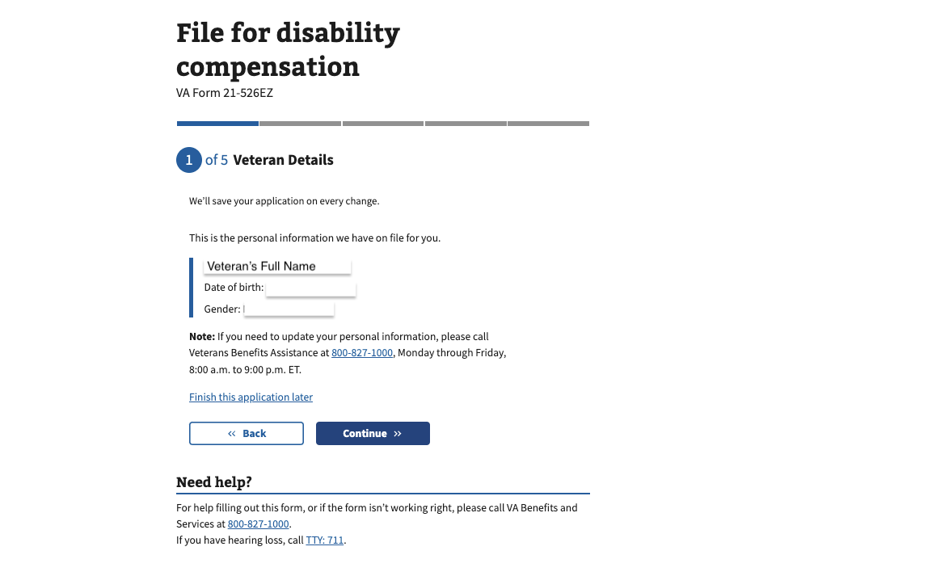

1. Next, verify this information. If it looks incorrect, click the edit button, make your revisions, and click save.

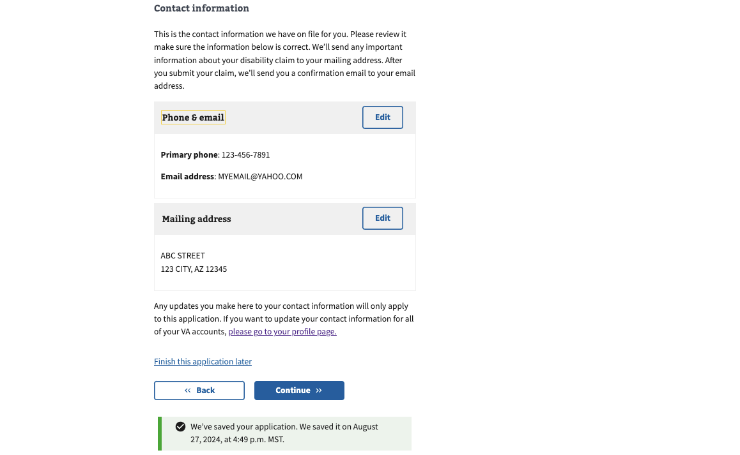

1. Now, if the following 2 questions are applicable, please answer them honestly and click continue.

Question 1:

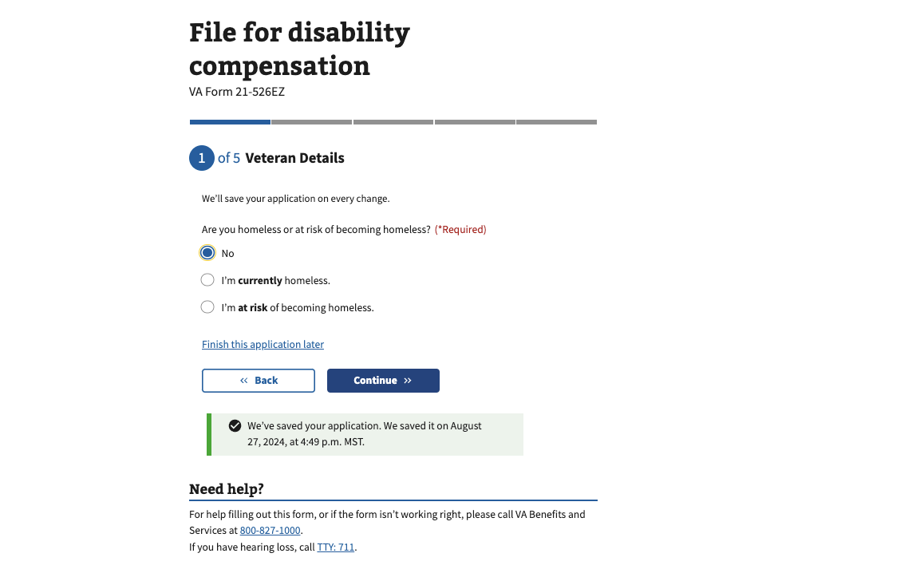

Question 2:

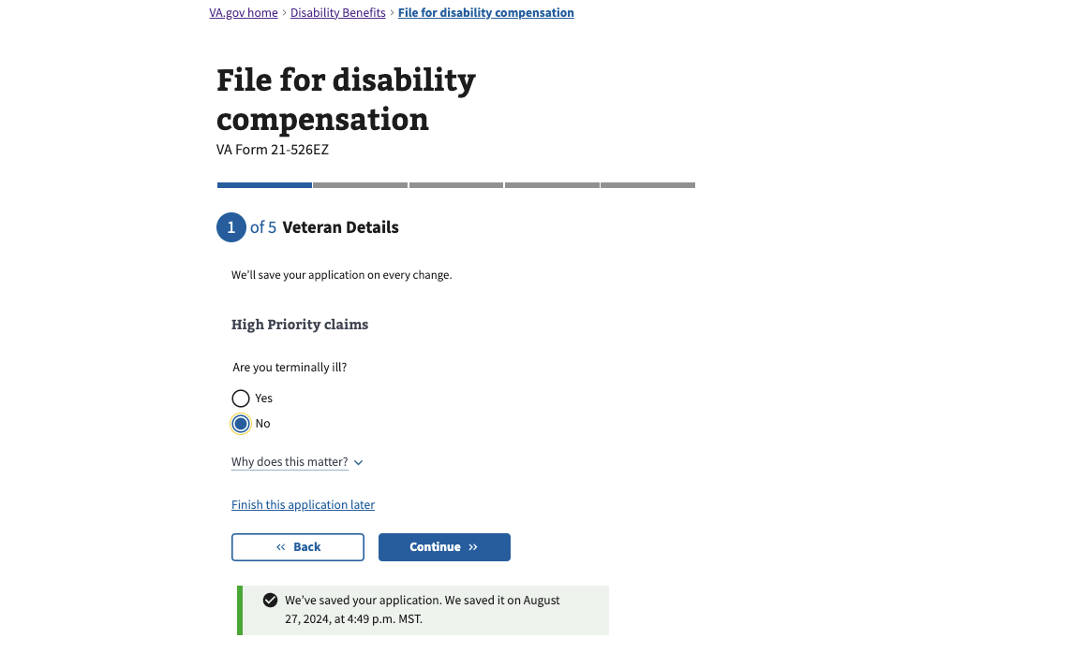

1. Lastly, use your DD214 to completely fill in your military service history -

* If you were Active Duty: add your service dates from your DD214 and click “finish this application later”.
  + If you didn’t serve in the Guard or Reserve and see a “Reserve” time period along with your active-duty time, that will be your IRR time and click “edit” then “remove”.
* If you were Guard or Reserves: add each separate service time corresponding with each DD214 and click “finish this application later”.

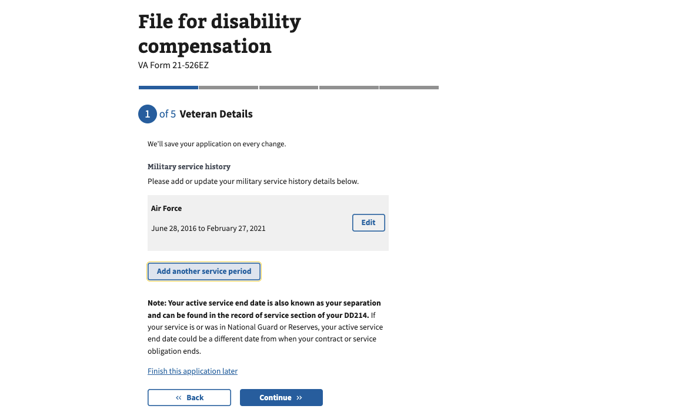

1. You are now finished with your Intent To File, click “finish this application later” and you may sign out. Next step will be sending us your documentation which include:

* Non-VA Civilian medical records to help support your VA claim in 98 megabytes per file.
* VA.GOV username and password.
* A complete copy of your military medical, dental, and mental health records in 98 megabytes per file.
* DD 214(s)

Please send these documents to: jamespittsconsulting1@gmail.com

